COLLEGE OF COMPUTER STUDIES AND MULTIMEDIA ARTS

IT0049
(WEB SYSTEM TECHNOLOGIES)

TECHNICAL SUMMATIVE ASSESSMENT
1

TASKS FOR TODAY MANAGEMENT SYSTEM

Student Name / Group Name: | Lukexander Virgilius P. De Guzman
Members (if Group):
  Name | Role
Section: | TC-32
Professor: | Sir Calleja

PROGRAM OUTCOME/S (PO) ADDRESSED BY THE LABORATORY EXERCISE
- Design, implement and evaluate computer-based systems or applications to meet desired needs and requirements. [PO: C]

COURSE LEARNING OUTCOME/S (CLO) ADDRESSED BY THE LABORATORY EXERCISE
- Apply advanced web development principles in creating, debugging, validating, and securing database-backed web applications. [CLO: 2]
- Design program flow and application structure for computing problems using CodeIgniter and Laravel frameworks. [CLO: 3]

INTENDED LEARNING OUTCOME/S (ILO) OF THE LABORATORY EXERCISE
At the end of this exercise, students must be able to:
- Design and implement a relational database schema for a small task-management application.
- Build Models and controllers that retrieve and filter records, including filtering by date.
- Produce multiple distinct views — a filtered dashboard, a full listing, a profile page, and a static page — from a shared data layer.

BACKGROUND INFORMATION
This assessment combines the two skills covered so far: organizing an application with MVC (Module 1) and backing it with a real database (Module 2). You will build a small internal tool, the Tasks for Today Management System, that a team could use to track daily to-do items.
A common pattern in dashboards like this is separating a filtered "today" view from a complete, unfiltered listing. Both views read from the same table; only the query differs. This activity asks you to implement both.

GRADING SYSTEM / RUBRIC
CRITERIA | Description
Functionality & Requirements Completeness (35 points max) | All required pages, records, and workflows are present and behave as specified in the activity instructions.
Code Structure & Organization (20 points max) | The application follows the framework's MVC conventions with a clear, consistent separation of concerns across controllers, models, and views.
Database Design & Data Retrieval (25 points max) | The schema is implemented as specified, sample data is realistic and sufficient, and queries correctly filter by date where required and retrieve all records where required.
Documentation & Submission Quality (20 points max) | The GitHub repository is organized and complete, the README explains how to set up and run the project, and the hosted link is live and matches the submitted code.

LABORATORY ACTIVITY
Build a Tasks for Today Management System with four pages: a Welcome page showing only today's tasks, a full Task List page showing every task, a Profile page showing one demo user's information, and an About page identifying you as the developer.
- Create the database and tables using the schema below:
CREATE TABLE tasks (
id INT AUTO_INCREMENT PRIMARY KEY,
title VARCHAR(150) NOT NULL,
status VARCHAR(20) NOT NULL DEFAULT 'pending',
task_date DATE NOT NULL,
created_at DATETIME NOT NULL
);

CREATE TABLE users (
id INT AUTO_INCREMENT PRIMARY KEY,
username VARCHAR(50) NOT NULL UNIQUE,
full_name VARCHAR(100) NOT NULL,
email VARCHAR(100) NOT NULL,
created_at DATETIME NOT NULL
);
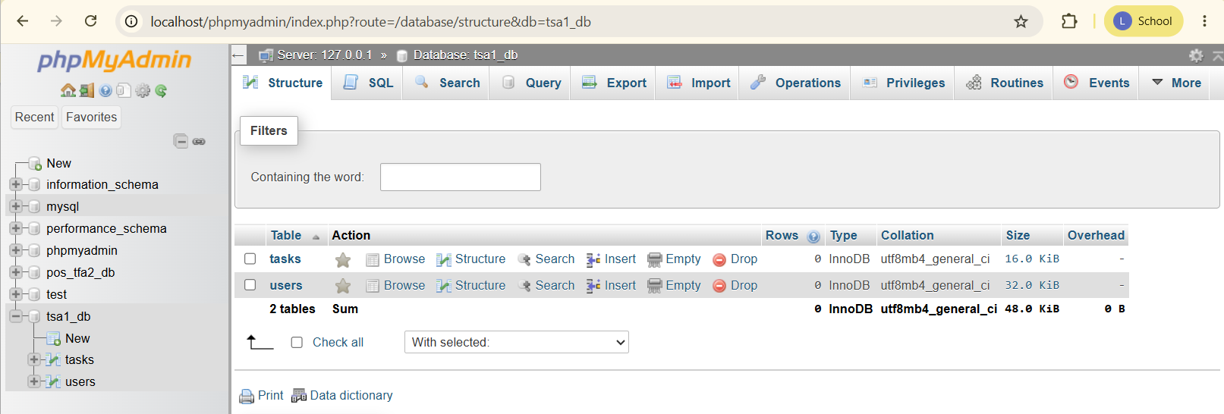

- Populate the tasks table with at least 8 records spanning at least 3 different dates, including today's date.
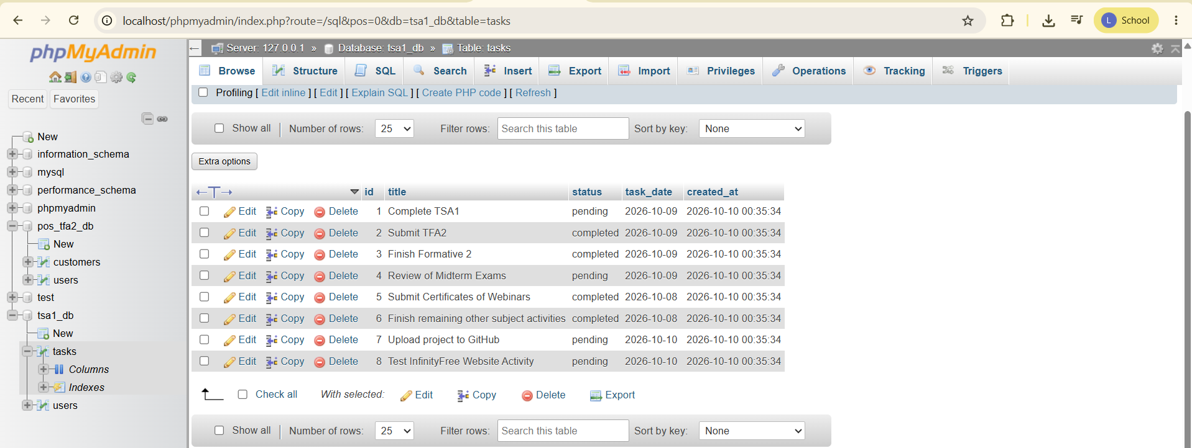

- Populate the users table with exactly one demo record.
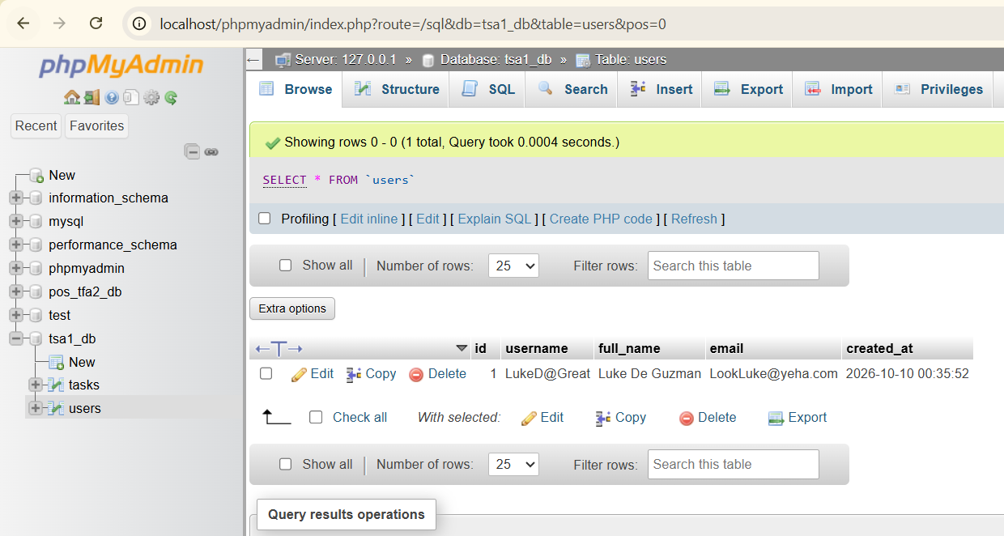

- Build a TaskModel and a UserModel.
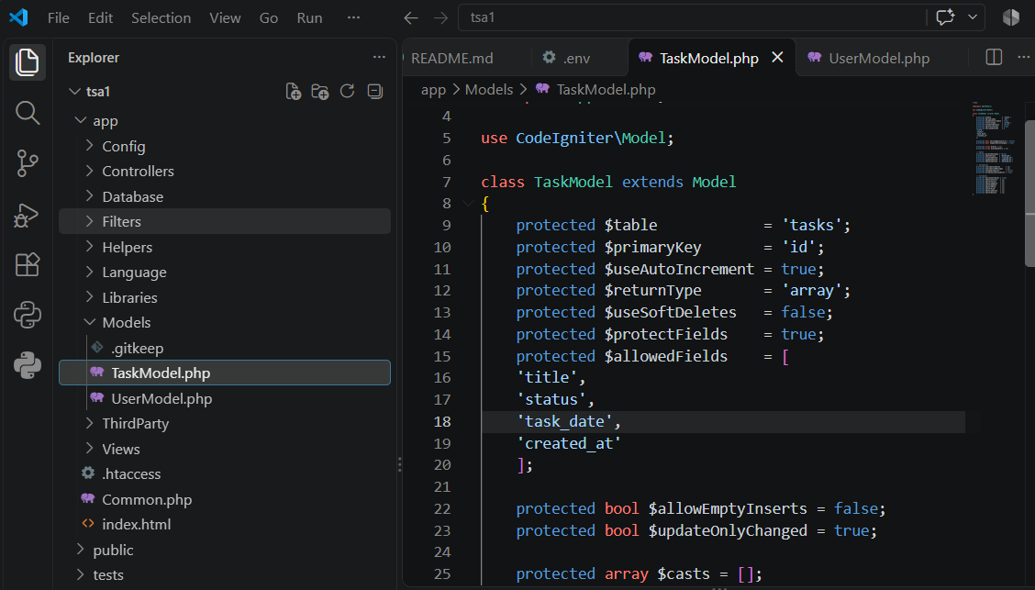
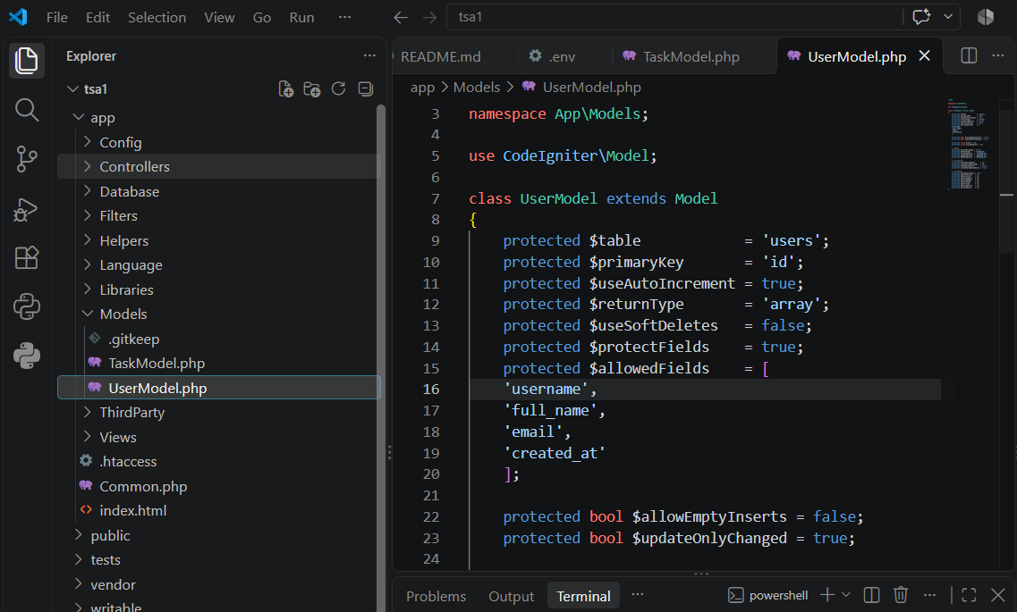
- Build the Welcome page (/) to query and display only tasks where task_date equals today's date.
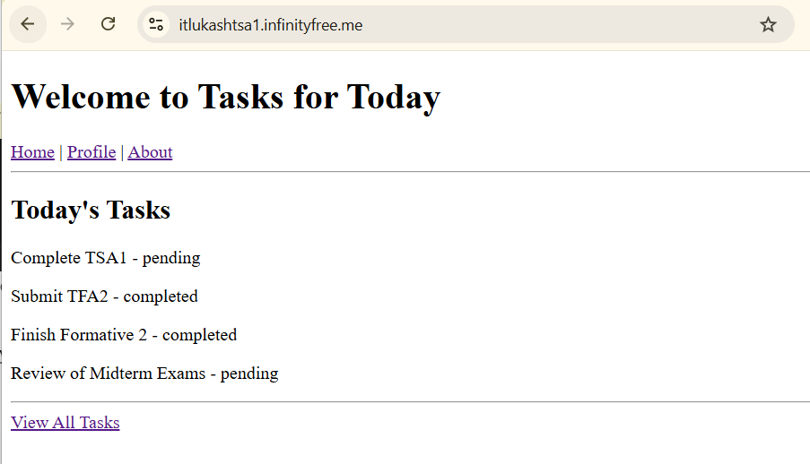
- Build the Task List page (/tasks) to query and display every task, ordered by date.
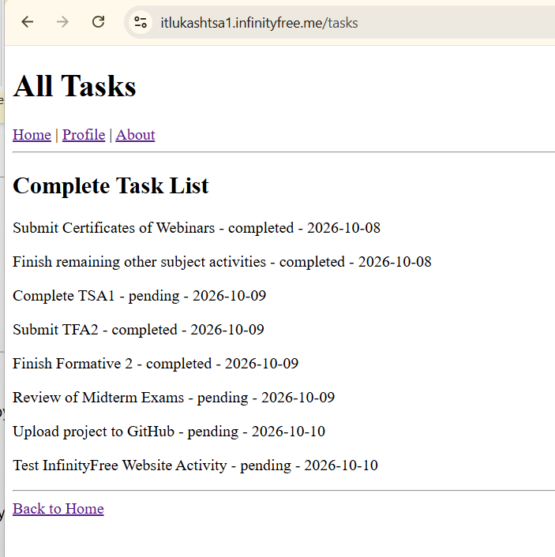

- Build the Profile page (/profile) to display the single user record.
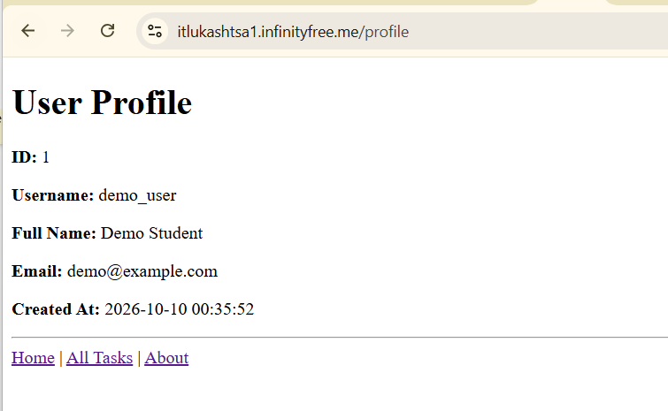
- Build a static About page (/about) identifying you as the developer of the system.
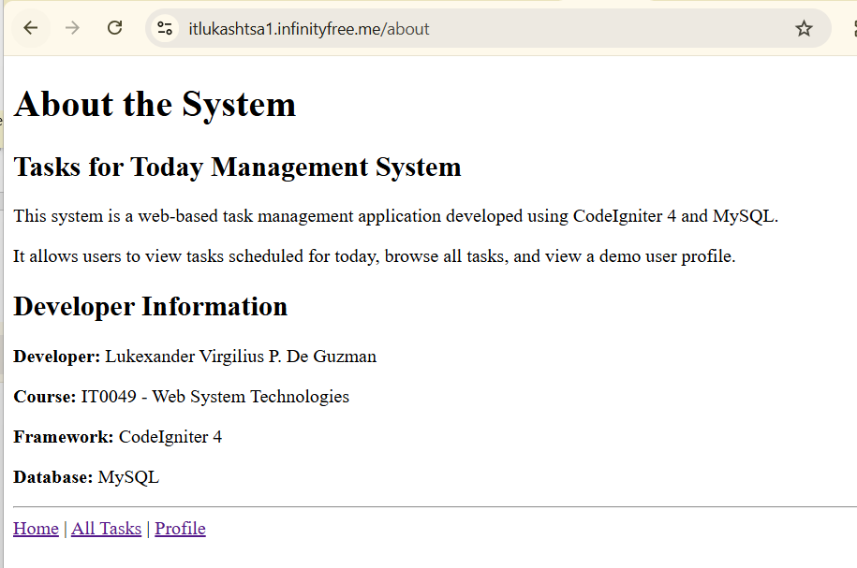
Submission Requirements:
- A link to a GitHub repository containing your raw project files, including your database export or migration and seeder files.

- A link to your hosted, working version of the application.
https://itlukashtsa1.infinityfree.me/

REFERENCES
- Manfield, A. (2021). Pro CodeIgniter: Learn how to create professional web-applications with PHP.
- CodeIgniter User Guide. Query Builder — Where Clauses. https://codeigniter4.github.io/userguide/database/query_builder.html

